**BLOOD BANK MANAGEMENT SYSTEM**

**REVIEW 1**

1. **ER DIAGRAM**

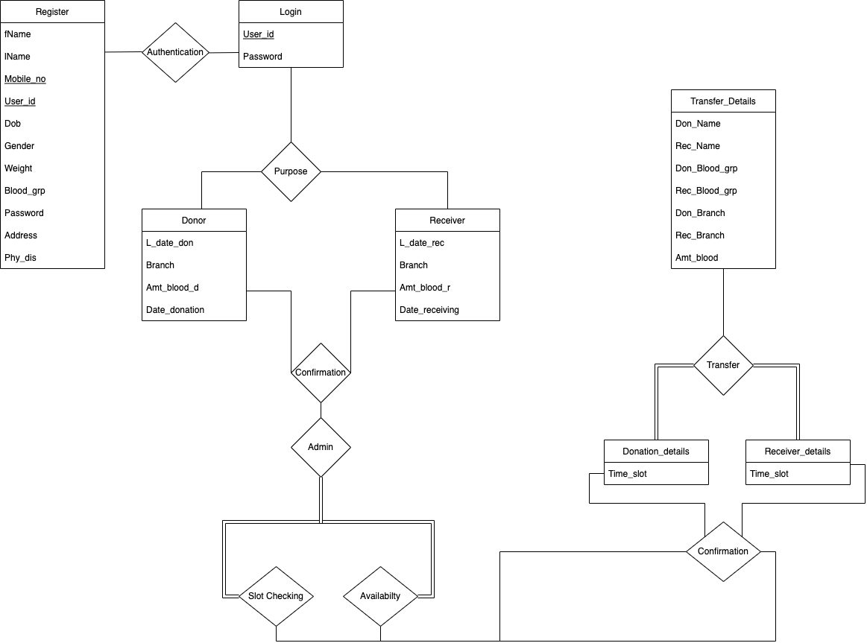

1. **SCHEMA DIAGRAM**

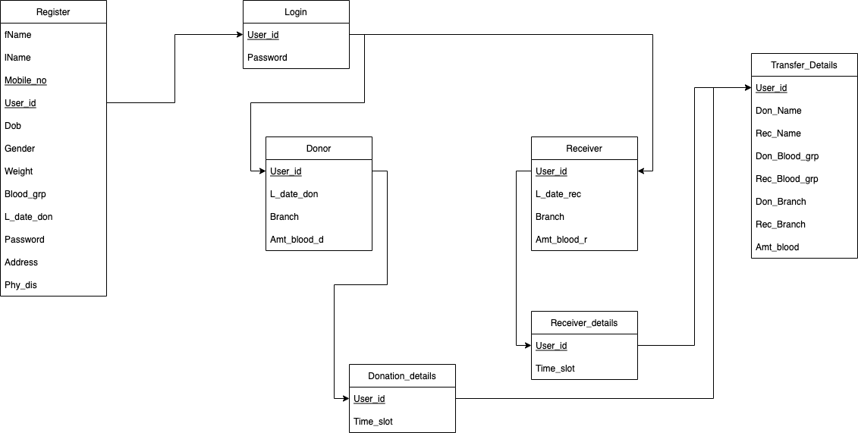

1. **RELATIONAL SCHEMA**

**Register (**fName, lName, Mobile_no, User_id, Dob, Gender, Weight, Blood_grp, L_date_don, Password, Address, Phy_dis**)**

**Login (**User_id, Password**)**

**Donor (**User_id ,L_date_don, Branch, Amt_blood**)**

**Receiver (**User_id**,** L_date_rec**,** Branch**,** Amt_blood**)**

**Donation_details (**User_id ,Time_slot**)**

**Receiver_details (**User_id, Time_slot**)**

**Transfer_Details (**Don_Name, Rec_Name, User_id, Don_Blood_grp, Rec_Blood_grp, Don_Branch, Rec_Branch, Amt_blood**)**

**GROUP MEMBERS**

1. SREESANKAR S - AM.EN.U4CSE20366
2. DEVESH KUMAR V V - AM.EN.U4CSE20321
3. VIGNESH A NAIR - AM.EN.U4CSE20374

**\*\*\*\*\*\*\*\*\*\*\*\*\*\*\*\*\*\*\*\*\*\*\*\*\*\*\*\***